2023 Forest City Mustang Invitational
Wednesday April 26th, 2023 @ Alumni Stadium Western University

2023 FOREST CITY/MUSTANG INVITATIONAL
TRACK AND FIELD MEET
Wednesday April 26th @ Alumni Stadium, Western University - London, ON
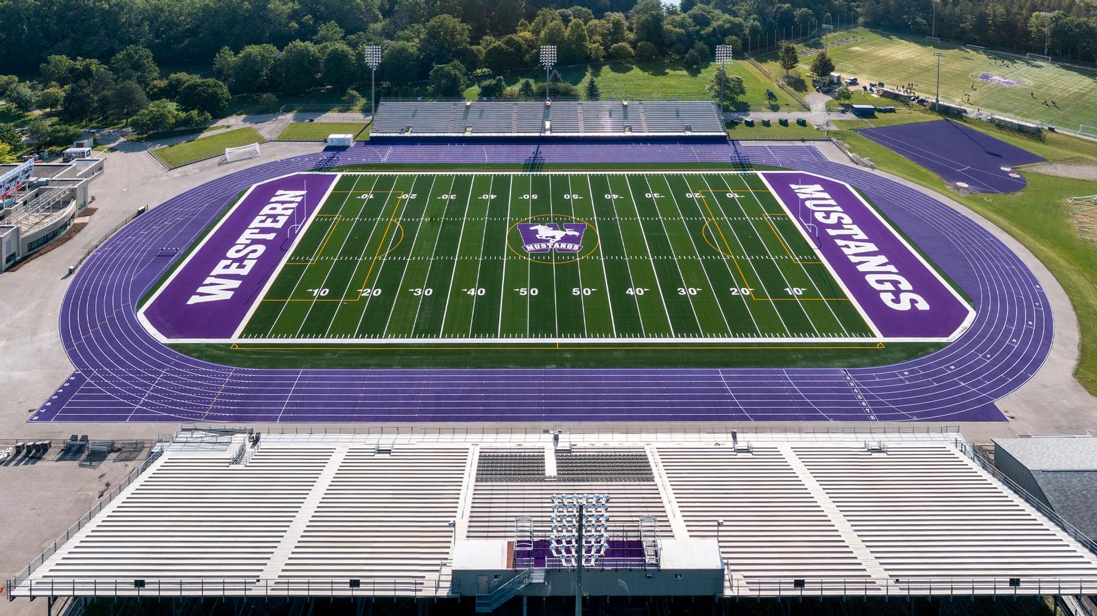Dear Coach:
Western’s Men’s and Women’s Track & Field teams and the London-Western Track and Field Club invite your school to participate in this year’s meet. The meet is on the Donald J. Wright Track at Alumni Stadium which was resurfaced in 2021 and is home of the 2024 OFSAA Track & Field Championships

www.westernmustangs.ca | www.londonwesterntfc.com
Meet Director – Taylor Ehrhardt
Taylorehrhardt10@gmail.com
519-639-0496

ENTRIES: Entries can be done at: http://www.trackiereg.com/ForestCityMustang2023
Deadline: Friday April 21st 2023 @ 11:59pm
Entry Fee: $15 per athlete or a maximum of $550 per school.
Max Entries: A limit of 6 athletes per event, per age category, per school. Each athlete is also limited to a total of 2 events.

Check-in: Last check in for track events will be 30min before the start of the race, for re-seeding to take place. All athletes that miss last check-in will be scratched from the race with no exceptions. Check-in for field events at the event site 30min before start time
Schedule: Final Schedule will be sent out once entries are closed, but the meet will not start any earlier than 11:00am

Results will be posted during the meet at: www.londonwesterntfc.com

TIMED SECTIONS: All track events will be run as a timed section final. Sections will be organized based on seed times and will run the fastest to slowest. Accurate seed times are critical. Unseeded athletes will be placed at the bottom of the start list, in the slower sections.

FIELD EVENTS: In horizontal jumps and all throws, each competitor will be given 3 attempts, (Time permitting) the top 8 receiving 3 more.

1st Legal attempt will be measured, all remaining attempts must surpass a minimum distance (TBD) in order to be measured.

POLE VAULT: Novice and Junior males/females with seed performances of 3.20m/2.80m or higher, respectively, will compete with senior age category.

ELIGIBILITY: All athletes competing in this meet must be registered through their respective schools. School uniform must be worn in competition.
AWARDS: Awards: t-shirt for 1st place, ribbons for standards achieved (TBD)

2023 FOREST CITY/MUSTANG INVITATIONAL
TENTATIVE TRACK SCHEDULE
TRACK EVENTS – Track events will be run from FAST to SLOW
Time | Last Check-in - TBD | Event | Divison
11:00am |  | 110mh | Senior Boys 36”
11:10am |  | 110mh | Junior Boys 36”
11:15am |  | 100mh | Novice Boys 33”
11:25am |  | 100mh | Senior Girls 30”
11:35am |  | 100mh | Junior Girls 30”
11:40am |  | 80mh | Novice Girls 30”
11:50am |  | 800m | Novice Girls
12:05pm |  | 800m | Junior Girls
12:20pm |  | 800m | Senior Girls
12:35pm |  | 800m | Novice Boys
12:50pm |  | 800m | Junior Boys
1:05pm |  | 800m | Senior Boys
1:20pm |  | 100m | Novice Girls
1:30pm |  | 100m | Junior Girls
1:40pm |  | 100m | Senior Girls
1:50pm |  | 100m | Novice Boys
2:00pm |  | 100m | Junior Boys
2:10pm |  | 100m | Senior Boys
 | Track Break
2:45pm |  | 400m | Novice Girls
3:00pm |  | 400m | Junior Girls
3:15pm |  | 400m | Senior Girls
3:30pm |  | 400m | Novice Boys
3:45pm |  | 400m | Junior Boys
4:00pm |  | 400m | Senior Boys
4:15pm |  | 1500m | Novice Girls
4:30pm |  | 1500m | Junior Girls
4:45pm |  | 1500m | Senior Girls
5:00pm |  | 1500m | Novice Boys
5:15pm |  | 1500m | Junior Boys
5:30pm |  | 1500m | Senior Boys
5:45pm |  | 200m | Novice Girls
6:00pm |  | 200m | Junior Girls
6:15pm |  | 200m | Senior Girls
6:30pm |  | 200m | Novice Boys
6:45pm |  | 200m | Junior Boys
7:00pm |  | 200m | Senior Boys

TENTATIVE FIELD SCHEDULE
Time | Event | Divison
11:00 | High Jump | Novice/Junior Girls
12:30 | High Jump | Senior Girls
2:00 | High Jump | Novice/Junior Boys
4:00 | High Jump | Senior Boys

Time | Event | Divison
12:00 | Pole Vault | Novice/Junior Girls
1:30 | Pole Vault | Senior Girls
3:00 | Pole Vault | Novice/Junior Boys
4:30 | Pole Vault | Senior Boys

Time | Event | Divison
11:00 | Long Jump (Pit 2) | Novice Girls
11:00 | Long Jump (Pit 3) | Junior Girls
11:00 | Long Jump (Pit 1) | Senior Girls
1:30 | Long Jump (Pit 2) | Novice Boys
1:30 | Long Jump (Pit 3) | Junior Boys
1:30 | Long Jump (Pit 1) | Senior Boys

Time | Event | Divison
3:00 | Triple Jump (Pit 2) | Novice Girls
3:00 | Triple Jump (Pit 3) | Junior Girls
3:00 | Triple Jump (Pit 1) | Senior Girls
5:00 | Triple Jump (Pit 2) | Novice Boys
5:00 | Triple Jump (Pit 3) | Junior Boys
5:00 | Triple Jump (Pit 1) | Senior Boys

Time | Event | Divison
11:00am | Shot Put | Novice/Junior Girls
12:30pm | Shot Put | Senior Girls
2:30pm | Shot Put | Novice/Junior Boys
4:00pm | Shot Put | Senior Boys

Time | Event | Divison
11:00am | Discus | Senior Boys
1:00pm | Discus | Novice/Junior Boys
2:30pm | Discus | Senior Girls
4:00pm | Discus | Novice/Junior Girls

Time | Event | Divison
11:00am | Javelin | Novice/Junior Boys
12:30pm | Javelin | Senior Boys
2:30pm | Javelin | Novice/Junior Girls
4:00pm | Javelin | Senior Girls

RESULTS: mustangstiming.com/Results/FCMI23

